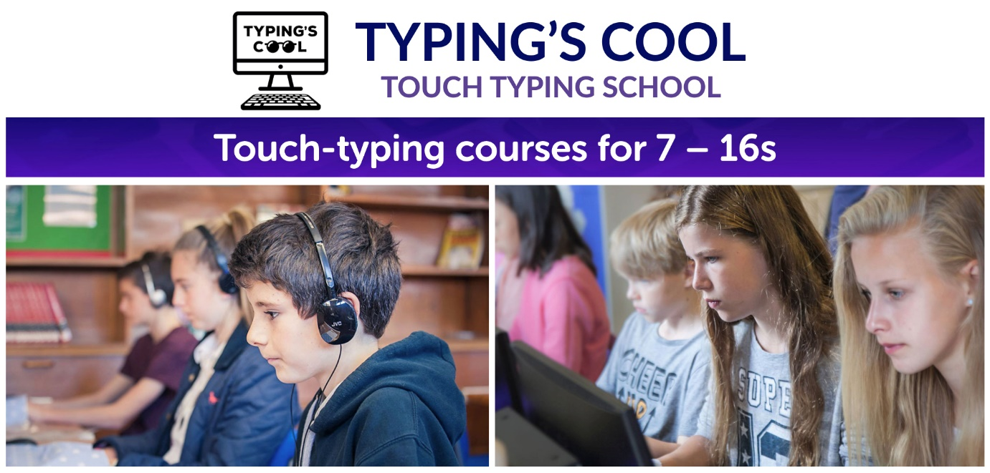
Autumn half term touch typing courses for 7 – 16s

Dulwich College, London SE21 7LD
Monday 26 to Thursday 29 October 2026
Sessions run 10:10 – 12:15 pm daily

(Full day care available on site)

Learn how to touch type 40+ words per minute with 95% accuracy. Using correct fingers and posture, touch typing is far more productive for schoolwork and exams.

Beginners, improvers and advanced typists are warmly welcome. We mix formal technique with the latest app games to make learning to type fast, fun and effective.

Flip flying skateboards, zap aliens and collect cool superhero movie rewards while learning an amazing skill. High-performance proficiency will significantly boost your child’s academic and exam attainment.

Prior to setting up Typing’s Cool, Sarah Holt worked as a teacher at Weston Green School and Nick Holt was a secondary school Head of English.

Cost: £176.00 per place
OFSTED registered - childcare vouchers accepted
10% discount for siblings/ returners/ bring a friend/ DofE (registered assessor).

Apply at www.typingscool.co.uk or contact sarah.holt@typingscool.co.uk

